 | AMERICAN INTERNATIONAL UNIVERSITY-BANGLADESH (AIUB)  Faculty of Engineering  Department of Electrical and Electronic Engineering

ELECTRONIC DEVICES LAB
*Rename your pdf file name as: SERIAL_NAME_ID_GR NO_ASSESSMENT NAME & NO.
Example: 09_AHMED RAHIM_22-12345-3_GR 03_LAB 01
*Report should be handwritten and PDF in format.
*Topics to be covered: Title >> Objectives >> Theory & Methodology >> Apparatus >> Results & Simulations >> Discussion & Conclusion >> Reference.
*Submit the report before the next lab class in the provided link (check portal notice).
SECTION: M | SEMESTER: SPRING 23-24
GROUP NUMBER: 5 | DATE OF SUBMISSION: 04/02/24
*Follow the upload rules during submission.
SUBMITTED BY
NAME: CHINMOY GUHA | ID: 22-48056-2
CLASS SERIAL NUMBER: 14 | CONTACT: 01706466663

LAB NO:01
TITLE: Determination of characteristic curve of a diode

Class SL | Group Member’s Name | ID | Contact Number
11 | FERDOUS, AMINA | 22-47822-2 | 01641586846
12 | UDDIN, MOHAMMAD ANSAR | 22-47975-2 | 01797180123
13 | TAIEB, ABDULLAH AL | 22-48028-2 | 01642511014
14 | GUHA, CHINMOY | 22-48056-2 | 01706466663
15 | CHAKRABORTY, SUVRA | 22-48067-2 | 01996088480

SUBMITTED TO:
SUJAN HOWLADER (ESSAN), ASSISTANT PROFESSOR
DEPARTMENT OF EEE, FACULTY OF ENGINEERING

Title and objective:
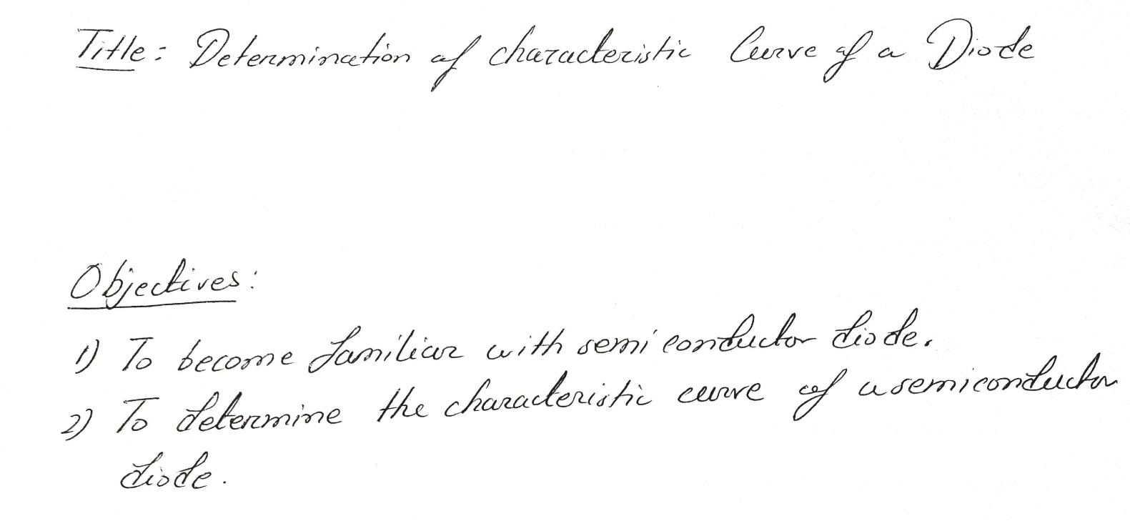

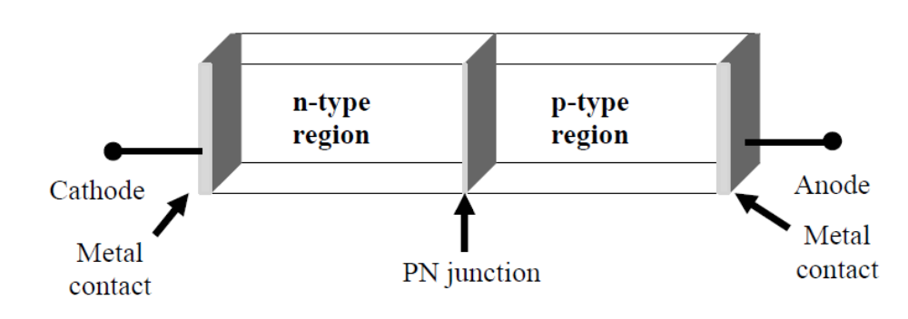

Figure 1: pn junction diode structure

Theory and Methodology:

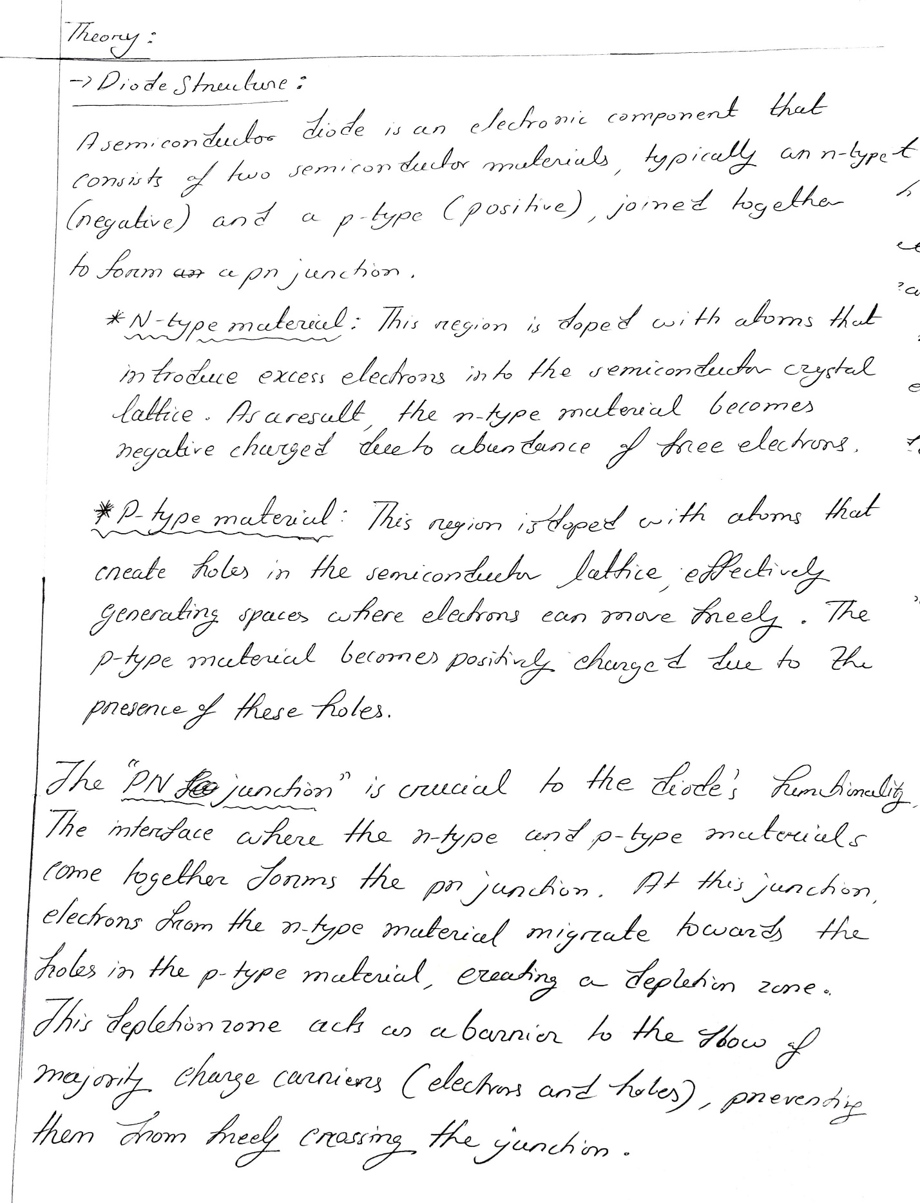

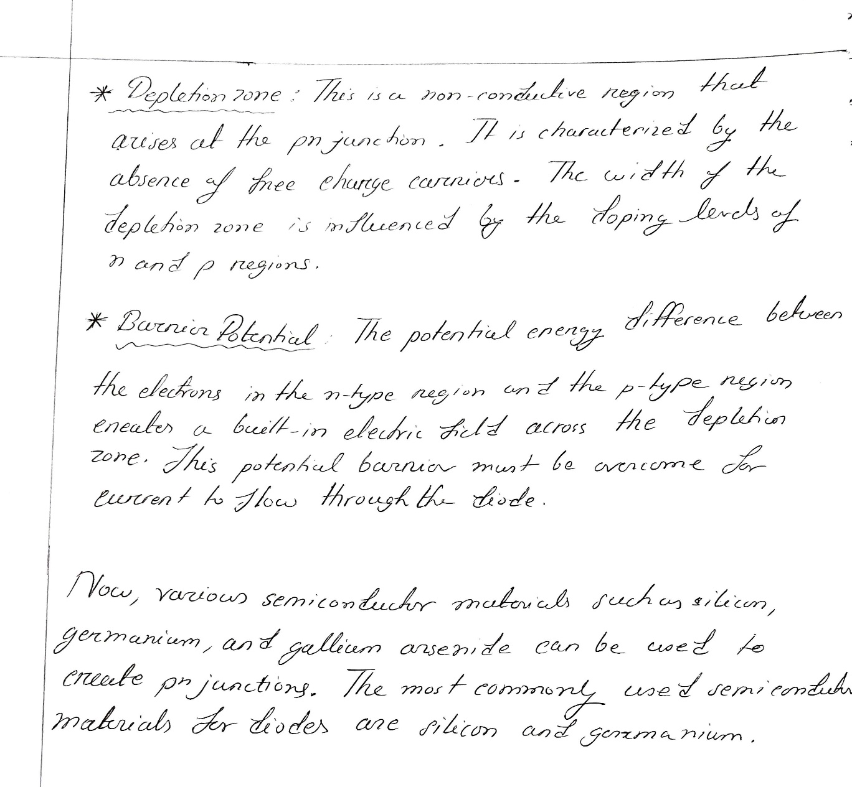

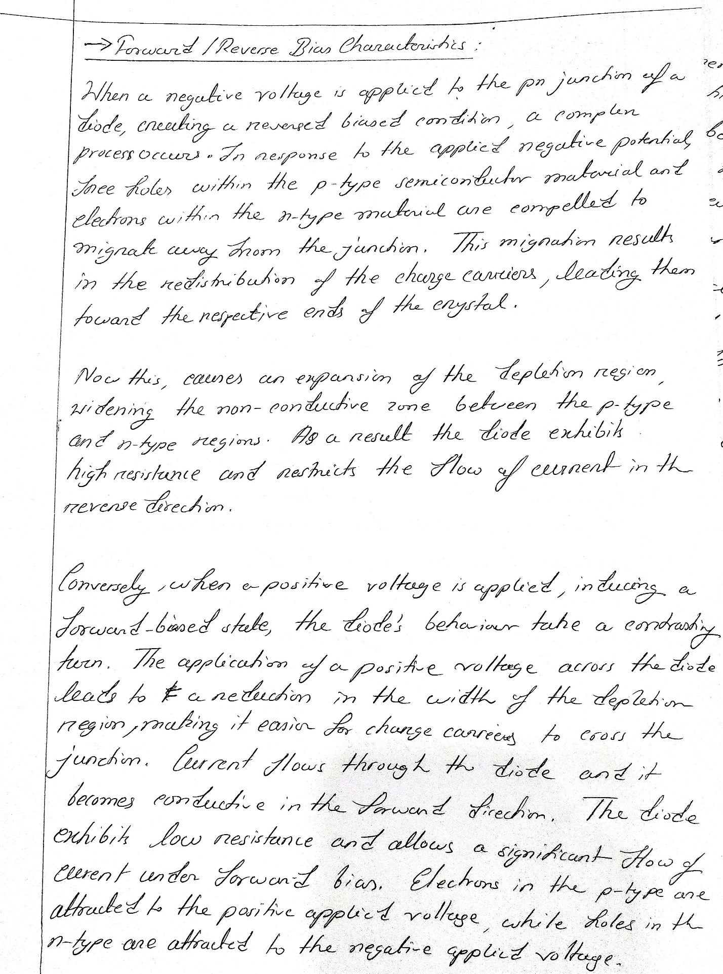
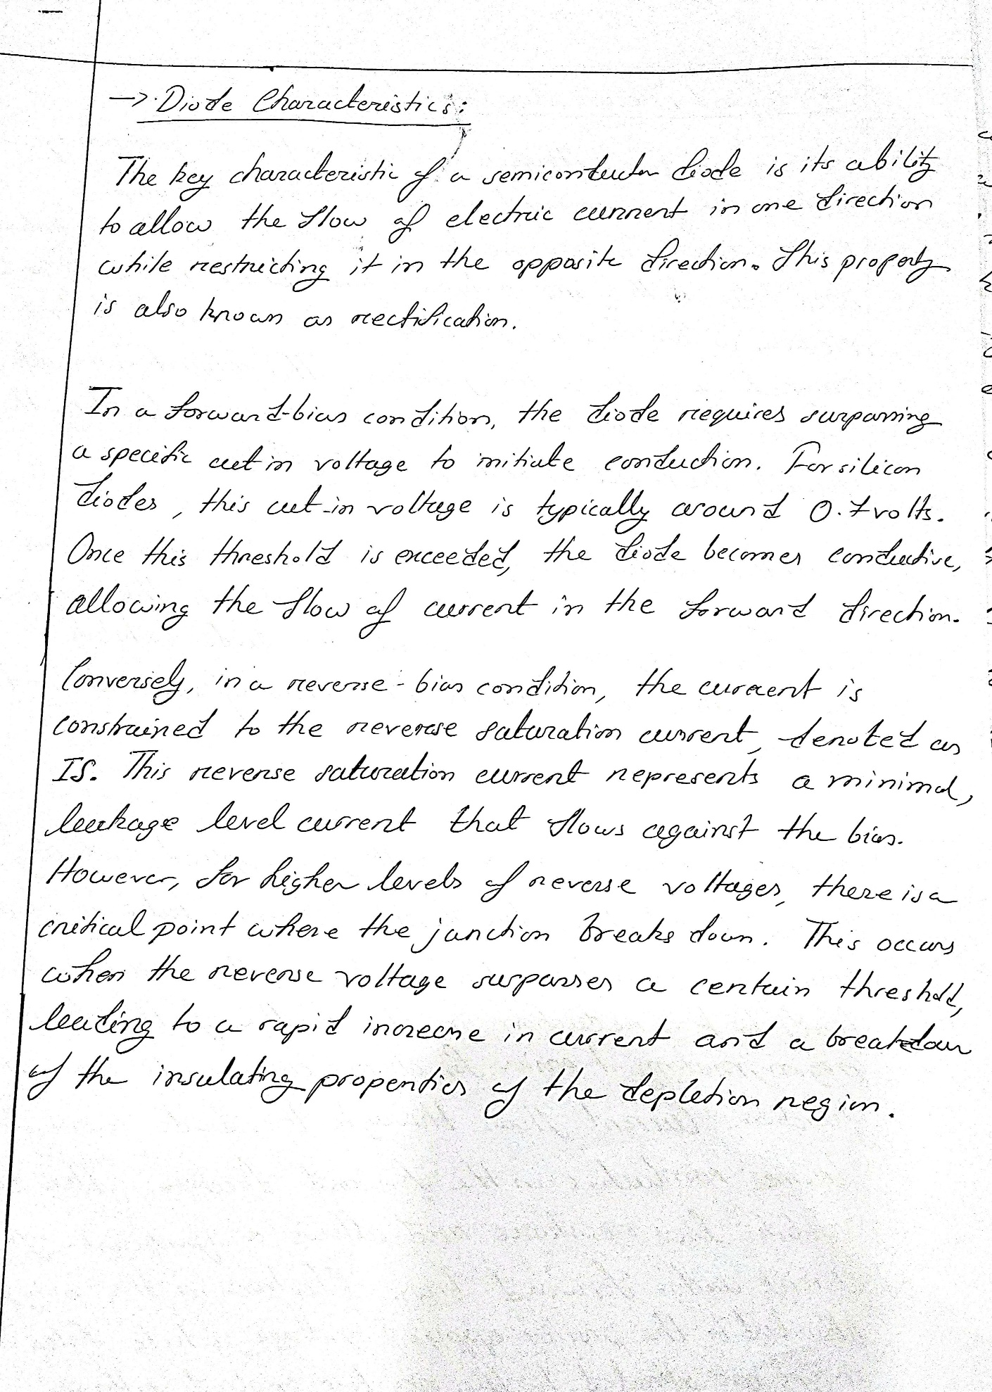

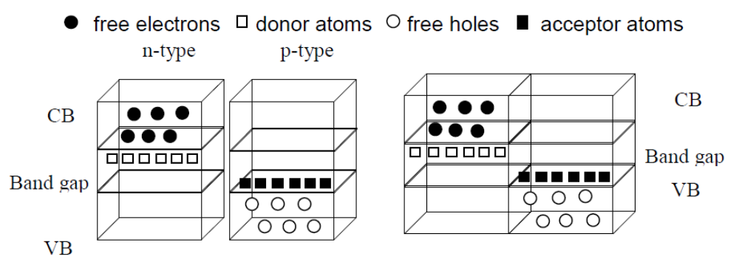
Figure 2: a) separate pieces b) pn junction

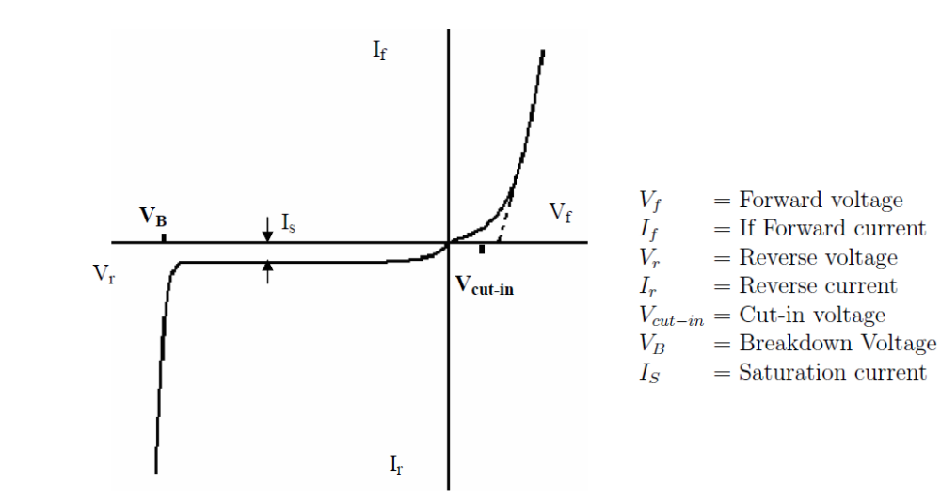
Figure 3: Diode IV Characteristics

Apparatus: 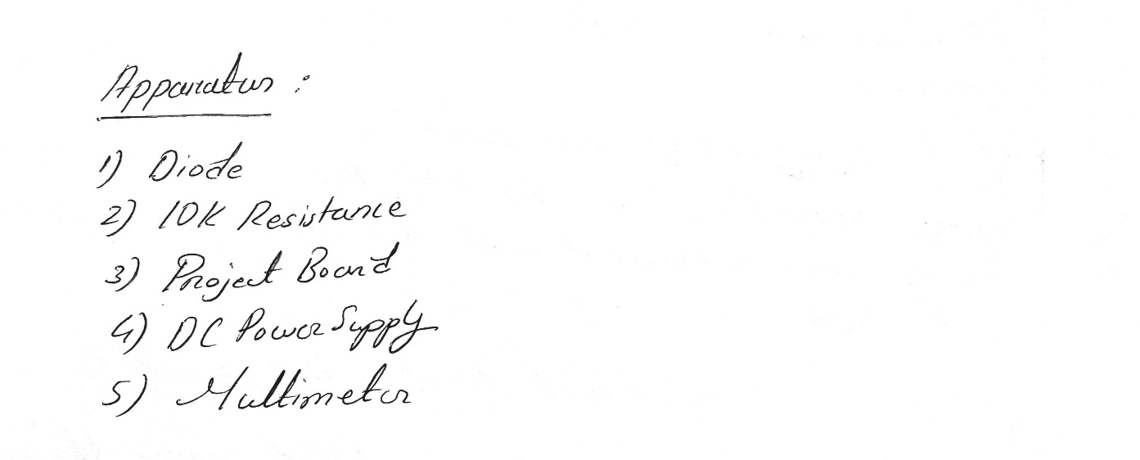
Experimental Procedure: 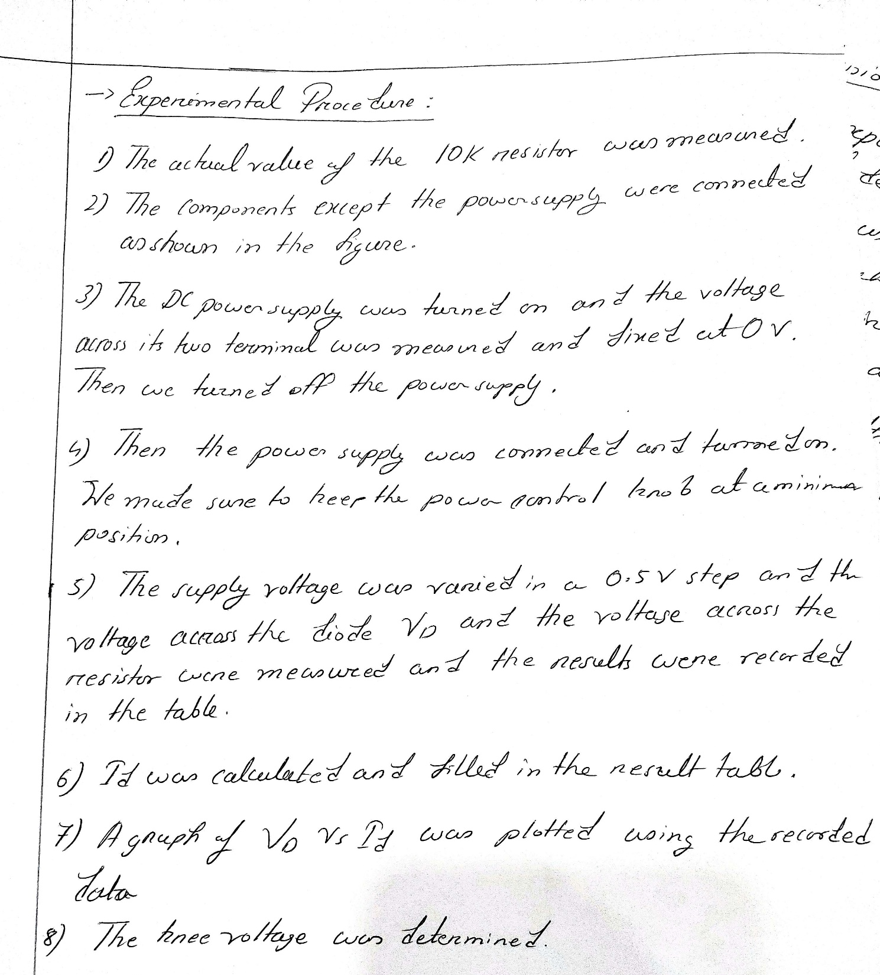

Results and Simulations:

Circuit:

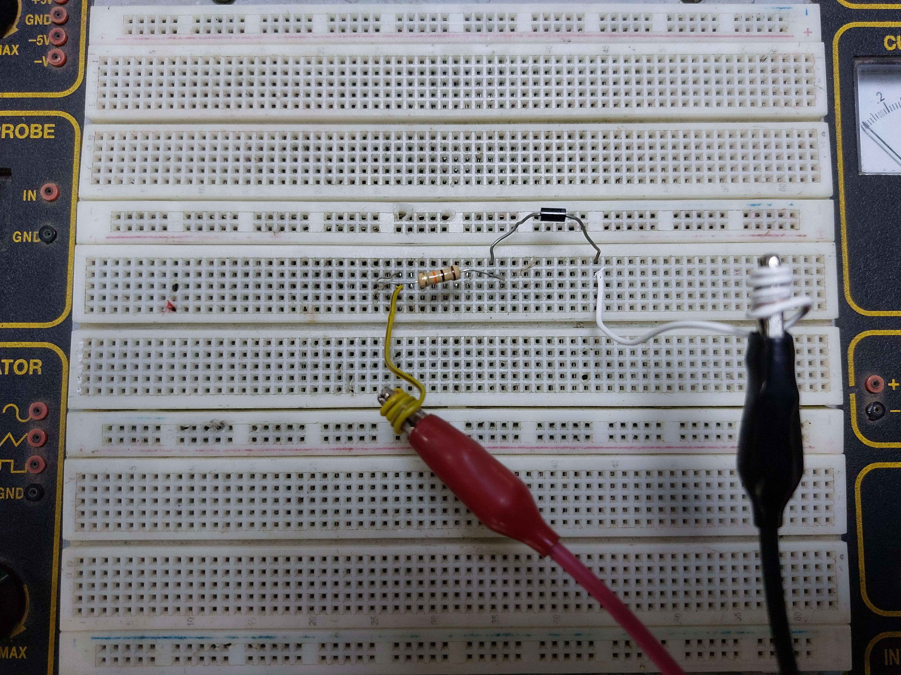

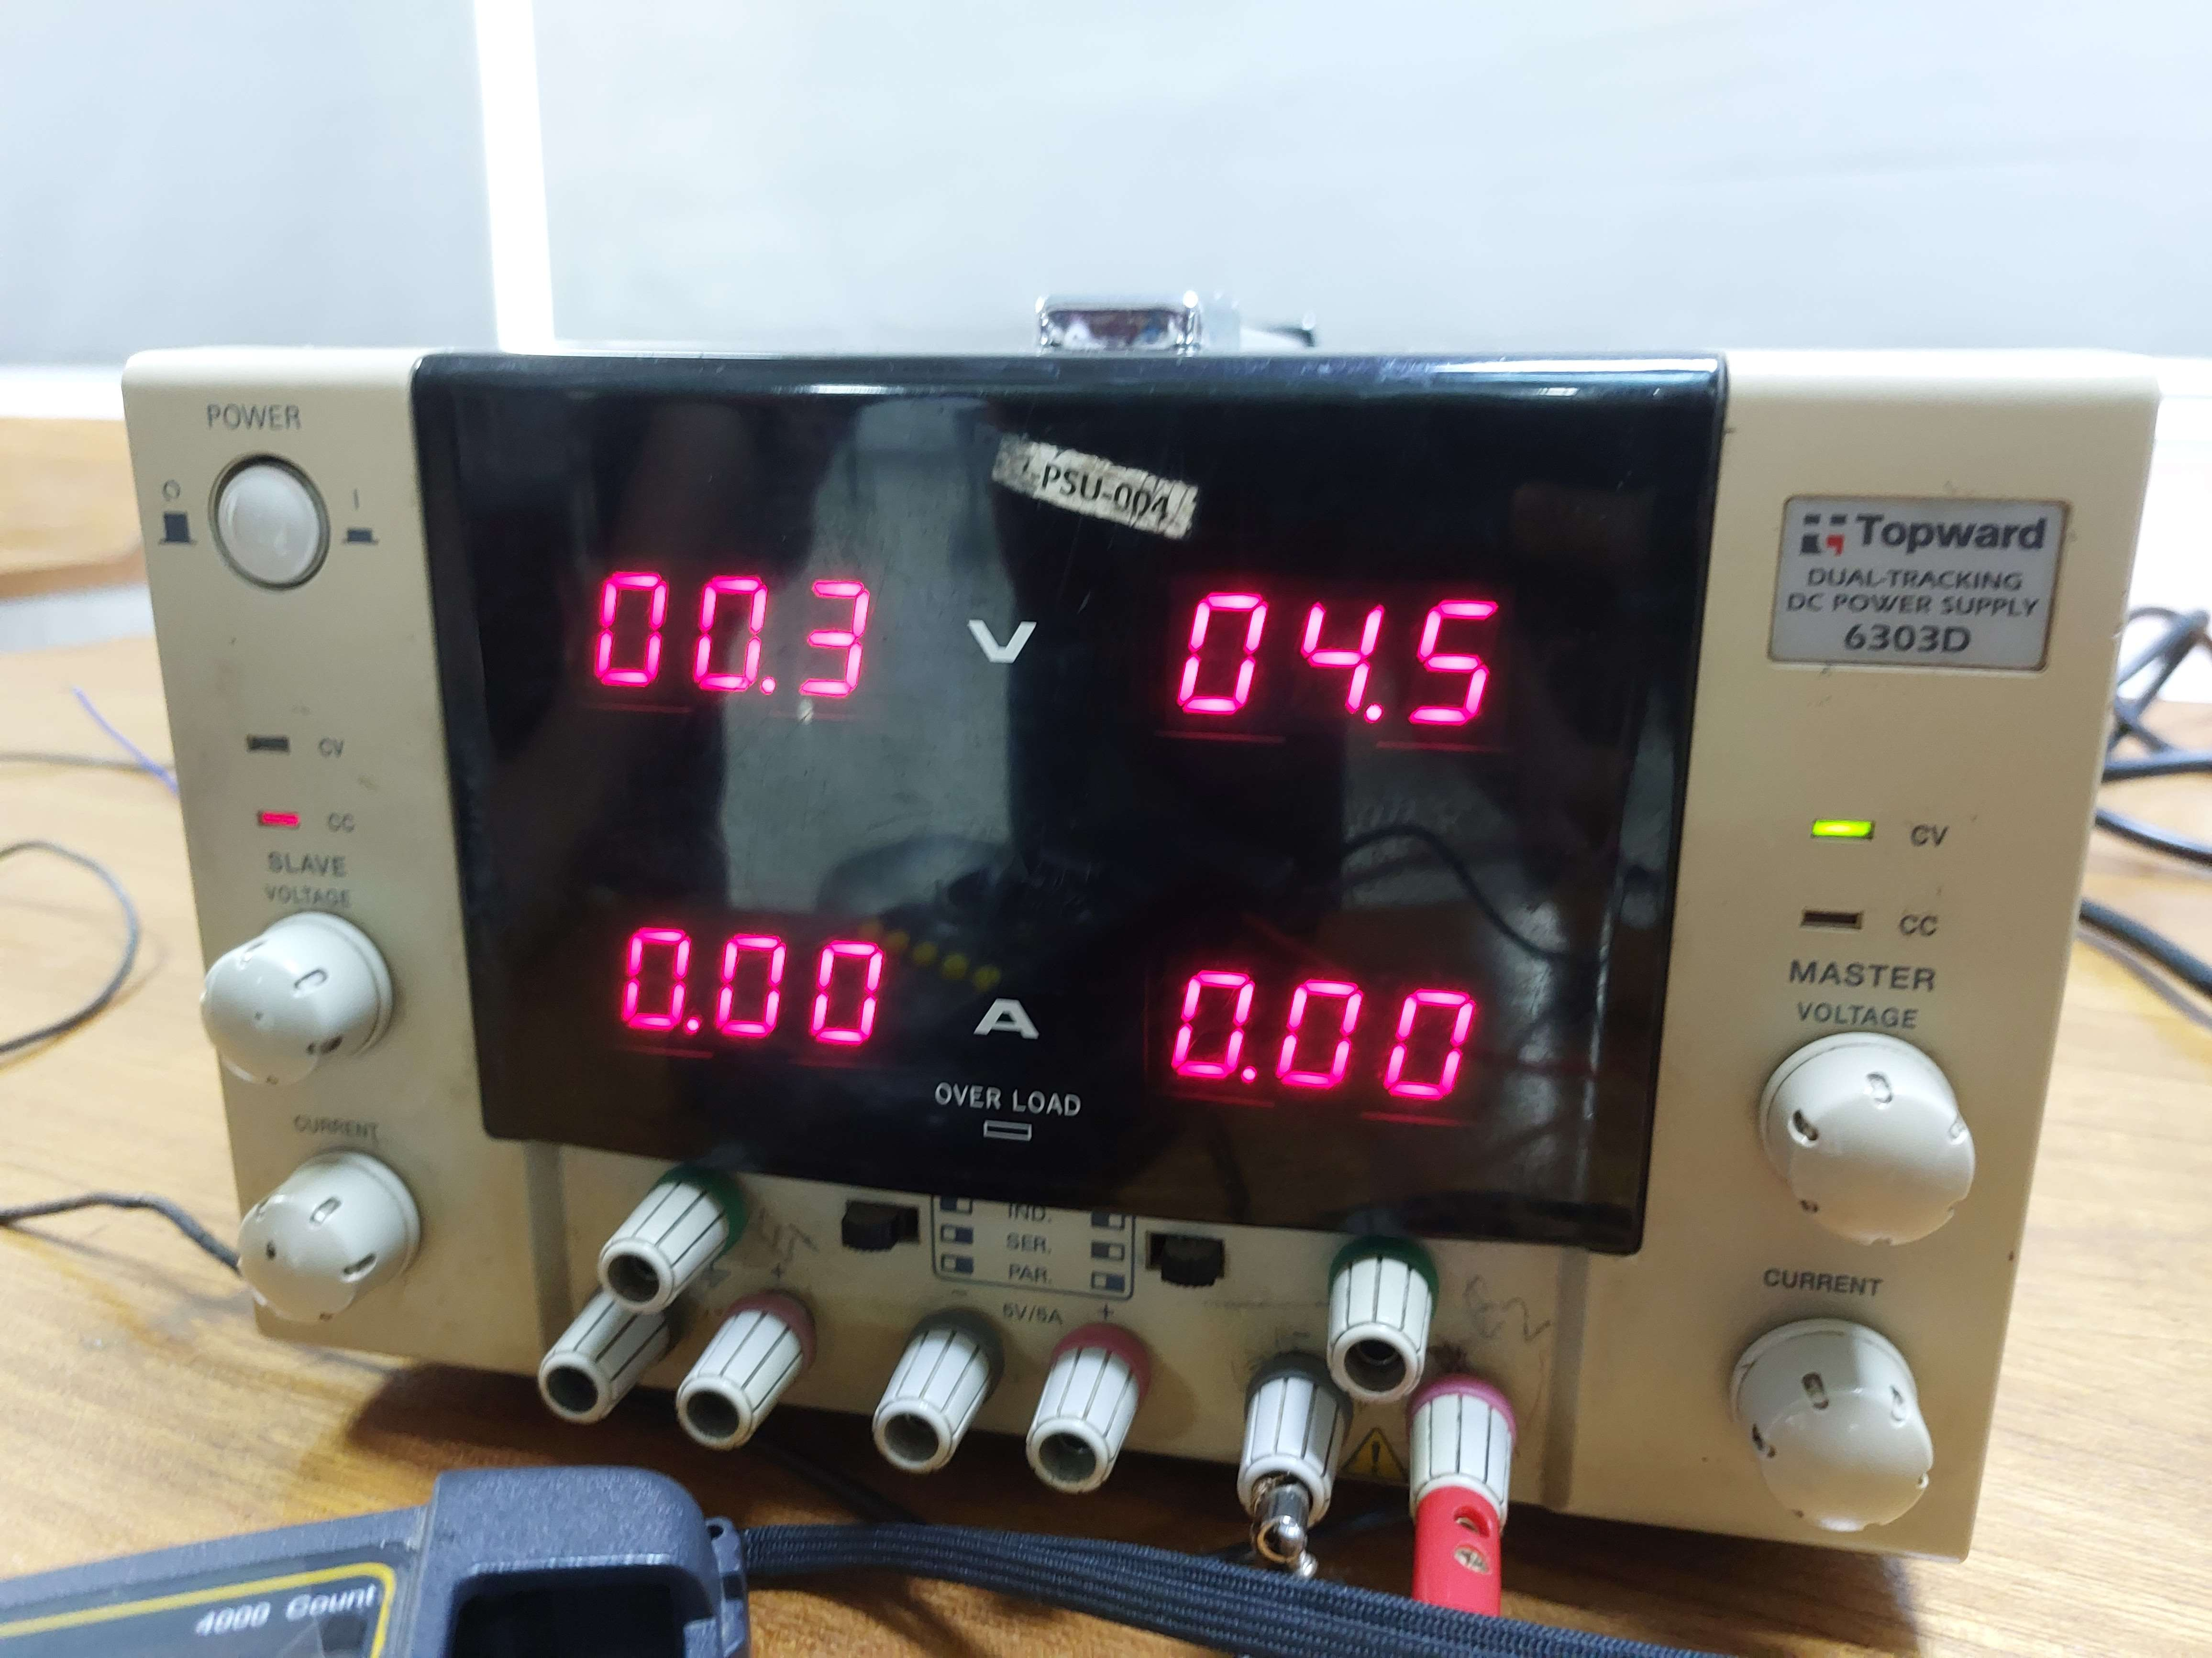

Data Table:

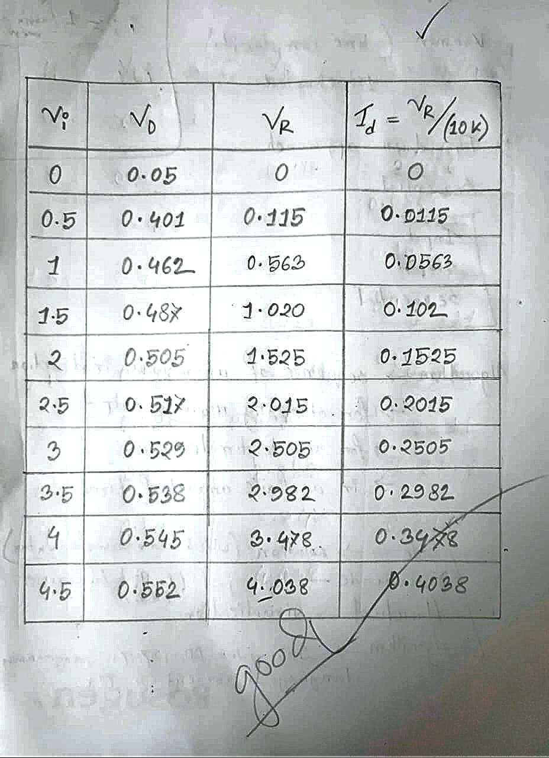

Graph of Id vs Vd:

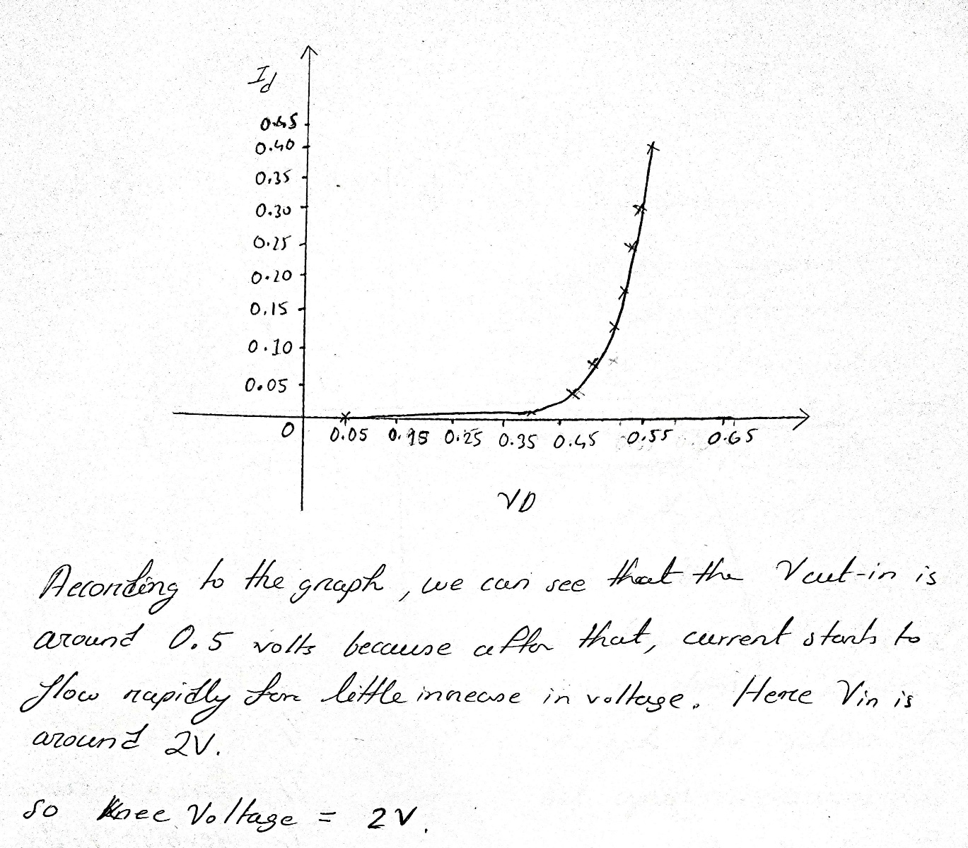

Simulation:
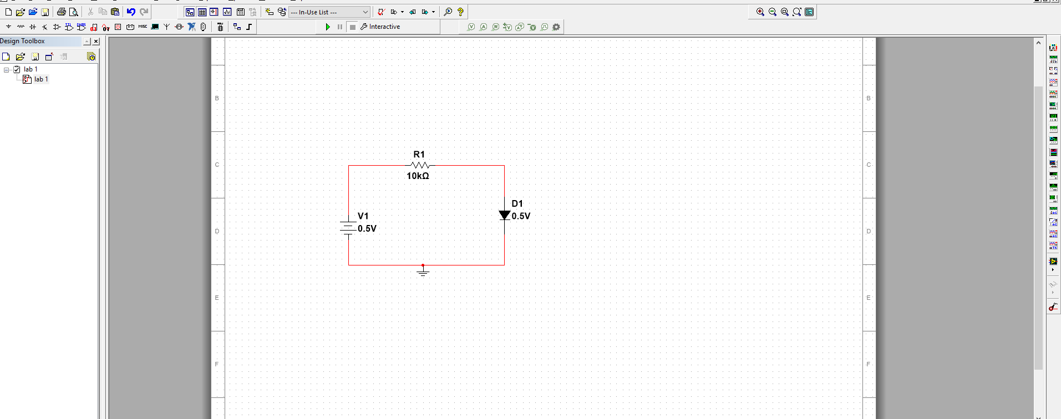

Discussion and Conclusion:
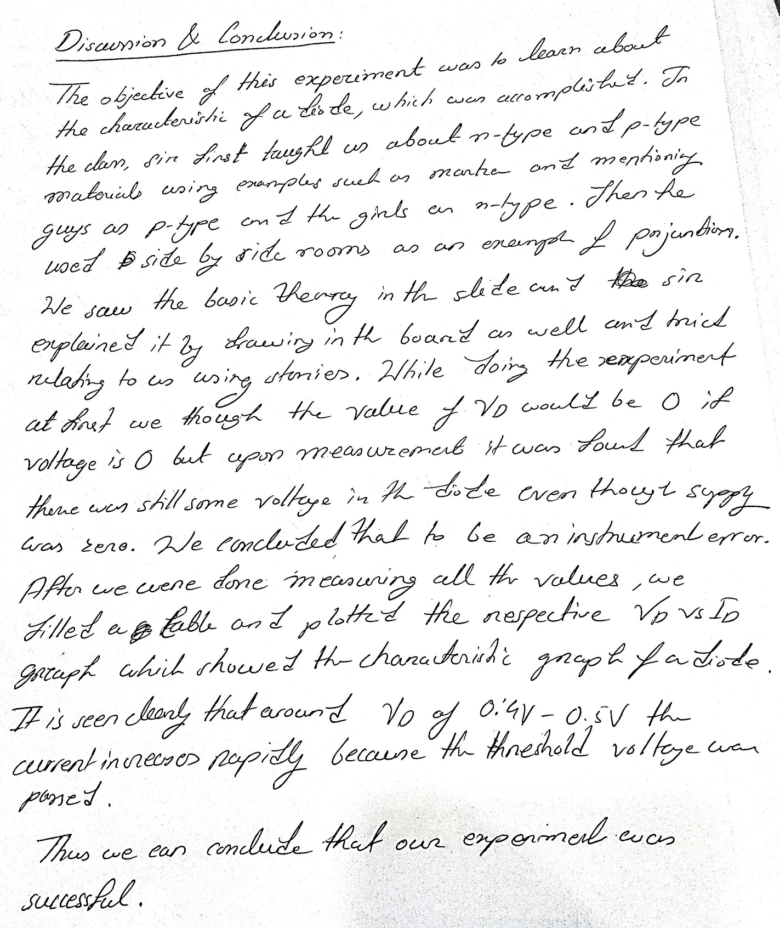

References:

1. Robert L. Boylestad, Louis Nashelsky, Electronic Devices and Circuit Theory, Ninth Edition, 2007-2008
2. Adel S. Sedra, Kennth C. Smith, Microelectronic Circuits, Saunders College Publishing, 3rd ed., ISBN: 0-03-051648-X, 1991.
3. American International University–Bangladesh (AIUB) Electronic Devices Lab Manual.
4. David J. Comer, Donald T. Comer, Fundamentals of Electronic Circuit Design,
john Wiley & Sons Canada, Ltd.; ISBN: 0471410160, 2002.
5. ChatGPT.
6. Energy Education : Diodes (https://energyeducation.ca/encyclopedia/Diode_operation)
7. Electronic tutorials (https://www.electronics-tutorials.ws/diode/diode_1.html

